Algebra 1: Unit 6, Lesson 10

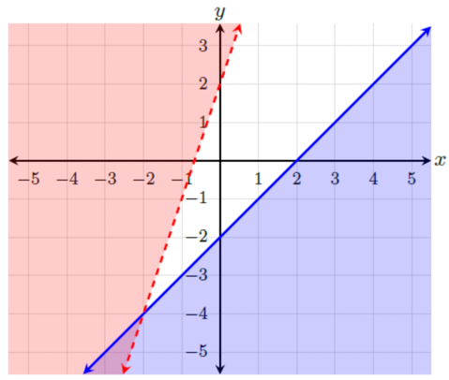
- The graph of the system of two inequalities, $y≤x-2$and $y>3x+2$, is shown.
Does the system have solutions and why?

Yes, because the regions of the two inequalities overlap.

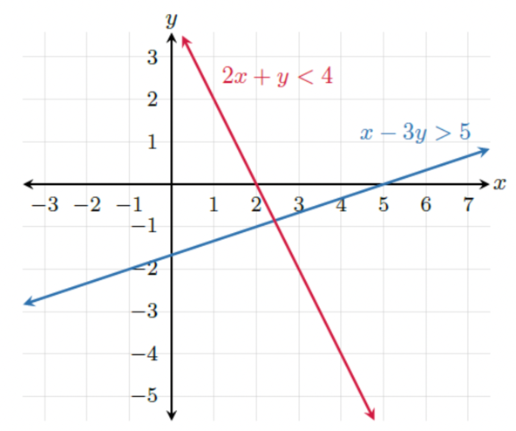
- The boundary lines of the system of two inequalities, $2x+y<4$ and $x-3y>5$, are shown.
Determine whether the point $(3,0)$ belongs in the solution set of inequality $2x+y<4$.
No, it is not in the solution set.

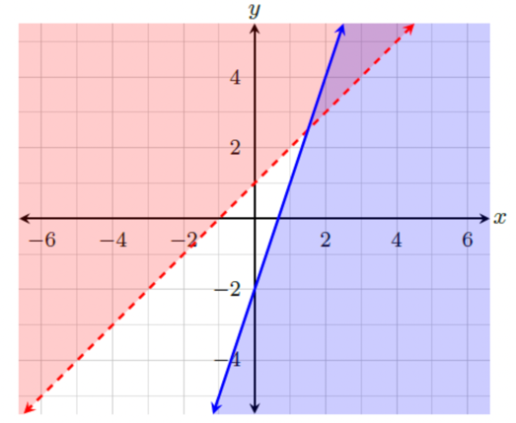
- A graph of a system of inequalities is shown.
Will the system of inequalities $y>x+1$ and
$-3x+y≤-2$ have the same solution?
Yes, it is the same solution set.

